**32**

**Alternating-Current Circuits**

|  |
| --- |
| **CHAPTER OUTLINE** |

32.1 AC Sources

32.2 Resistors in an AC Circuit

32.3 Inductors in an AC Circuit

32.4 Capacitors in an AC Circuit

32.5 The RLC Series Circuit

32.6 Power in an AC Circuit

32.7 Resonance in a Series RLC Circuit

32.8 The Transformer and Power Transmission

* An asterisk indicates a question or problem new to this edition.

|  |
| --- |
| **SOLUTIONS TO THINK – PAIR – SHARE AND ACTIVITIES** |

**\*TP32.1 Conceptualize** Be sure you are clear on the resonant behavior of an *RLC* circuit as discussed in Section 32.7. Equation 32.38 shows the rms current in the circuit, which, of course, maximizes at the same frequency for all three elements. The voltage across each element, however, depends on both the current and the reactance, so it maximizes at a different frequency for each element.

**Categorize** The circuit in question is an *RLC* circuit, so we can use the material we studied in Sections 32.5 and 32.7.

**Analyze** (a) Take the ratio of the magnitude of the output voltage across the inductor, using Equation 32.15, to the magnitude of the voltage across the capacitor, using Equation 32.23:



The question asks about the relationship between the voltages at resonance, so substitute the frequency at resonance from Equation 32.39:



(b) Take the ratio of the magnitude of the output voltage across the resistor, using Equation 32.5, to the magnitude of the voltage across the inductor, using Equation 32.15:

 (1)

This ratio is either larger than 1 or smaller than 1, depending on the particular values of *R*, *L*, and *C*:



Because the output voltage across the capacitor has the same magnitude as that across the inductor at resonance, the same conditions (2) and (3) hold if ∆*vL* is replaced with ∆*vC*. Finally, all three output voltages have the same magnitude at resonance when

 (4)

(c) From Equation 32.38, the current in the circuit at any frequency is

 (5)

From Equation 32.15, the magnitude of the voltage across the inductor is

 (6)

We can simplify this expression a little by multiplying both numerator and denominator by *C*:

 (7)

Differentiate Equation (7) and set the result equal to zero to find the frequency at which the magnitude of the voltage across the inductor maximizes:



From Equation 32.23, the magnitude of the voltage across the capacitor is

 (9)

We can simplify this expression a little by multiplying both numerator and denominator by *C*:

 (10)

Differentiate Equation (10) and set the result equal to zero to find the frequency at which the magnitude of the voltage across the capacitor maximizes:



Now divide Equation (8) by Equation (11):



Substitute the resistance from Equation (4) in part (b) into Equation (12):



**Finalize** Perhaps it is satisfying to see somewhat complicated expressions reducing to just 2 at the end of part (c)!]

*Answer:* (b) 

**\*TP32.2** (a) At high frequencies, the capacitor acts as if it is almost a continuous wire, because the reactance in Equation 32.21 is very low, so the voltage across it is small. Therefore, the voltage across the resistor will be equal to the input voltage. (b) At low frequencies, the capacitor acts as if it is almost a break in the wire, because the reactance in Equation 32.21 is high, so the voltage across it is equal to the input voltage.

Possibility (i) is called a *high-pass filter*. The output voltage is low for low frequencies and rises to the input voltage as the frequency becomes very high. Figure ANS TP32.2a shows the behavior of the ratio of the output voltage to the input voltage as a function of frequency.

**[Fig. ANS TP32.2a = New (see submitted file "9781337553278_Serway_PSE10e_Ch32_Figure_ANS_TP32.2a.jpg") ]**

Possibility (ii) is called a *low-pass filter*. The output voltage is equal to the input voltage for very low frequencies and approaches zero as the frequency becomes very high. Figure ANS TP32.2b shows the behavior of the ratio of the output voltage to the input voltage as a function of frequency.

**[Fig. ANS TP32.2b = New (see submitted file "9781337553278_Serway_PSE10e_Ch32_Figure_ANS_TP32.2b.jpg") ]**

An *RLC* circuit acts as a crude *band-pass filter,* with large output voltage near the resonance frequency. Band-pass filters with a more “flat” response can be designed with combinations of *RLC* circuits.

*Answers:* (a) (i) (b) (ii)

**\*TP32.3 Conceptualize** Remind yourself of the details of connecting elements in parallel to the voltage source. Since all elements are connected directly to the source, they all must have the same voltages across them.

**Categorize** We didn't study the parallel *RLC* circuit in the chapter, but we can apply the material studied in Sections 32.5 and 32.7 to this new circuit.

**Analyze** (a) The current in each element must be equal to the voltage across the element divided by its impedance. As with any parallel circuit, the current from the voltage source must equal the sum of the currents in the individual elements. Because of the phasor relationship shown in Figure TP32.3b, we must have



Using Equations 32.6 and 32.8, we find



(b) From the phasor diagram, we see that



(c) At resonance *XC* = *XL*, so Equation (1) becomes



This is the minimum value because any nonzero value of *XC* – *XL* increases the value of *I*rms.

(d) In general, the rms current in a circuit is related to the rms voltage and impedance of the circuit according to an rms version of Equation 32.29:

 (2)

Comparing Equations (1) and (2), we see that

 (3)

**Finalize** Notice that some of the results for the parallel *RLC* circuit look somewhat similar to those for the series circuit, but there are some clear differences. Equation (3) can be written as



Compare this expression for the impedance for the parallel *RLC* circuit to that for the series *RLC* circuit in Equation 32.28. Another major difference is that the parallel circuit is an *antiresonator,* as seen in part (c): the current reaches a *minimum* at resonance.

**Answers:** (d)

**\*TP32.4 Conceptualize** Notice that the current is not varying sinusoidally, as were the currents in the discussions in this chapter. Notice also that we are given the *current,* and we want to find the *voltage* in part (b).

**Categorize** The circuit is a simple one formed from a time-varying voltage source and an inductor. Note that the source voltage is periodic but not sinusoidal.

**Analyze** (a) The expressions for *i*(*t*) in each of the two segments of every second are recognized as linear functions. Therefore, we graph them as lines with the slopes and intercepts given in the expression:

**[Fig. ANS TP32.4a (see submitted file "9781337553278_Serway_PSE10e_Ch32_Figure_ANS_TP32.4a.jpg") ]**

(b) From Equation 31.1, we have the voltage across the inductor:

 (1)

Therefore, the voltage across the inductor is proportional to the time derivative of the current. Because the current varies linearly with time, the derivative of the current is just the constant slope of the current graph. Therefore, for each second,



Carrying out the multiplications gives us



Graphing this function gives us

**[Fig. ANS TP32.4b (see submitted file "9781337553278_Serway_PSE10e_Ch32_Figure_ANS_TP32.4b.jpg") ]**

**Finalize** This turned out to be a relatively simple exercise in applying the equation for the voltage across an inductor to a nonsinusoidal situation.

*Answers:* (a) **[see submitted file "9781337553278_Serway_PSE10e_Ch32_Figure_ANS_TP32.4a.jpg"]**

(b) **[see submitted file "9781337553278_Serway_PSE10e_Ch32_Figure_ANS_TP32.4b.jpg"**

|  |
| --- |
| **SOLUTIONS TO END-OF-CHAPTER PROBLEMS** |

Section 32.2 Resistors in an AC Circuit

**P32.1** The rms voltage is



(a) 

(b) 

**P32.2** (a) We compute the peak voltage from the rms voltage:



(b) From the definition of power,



Solving for the resistance,



(c) 

**P32.3** The current as a function of time is  Given the value of *t*, we want to identify a point with



or = sin–1 0.600

To find the lowest frequency we choose the smallest angle satisfying this relation:



Thus,  so 

**P32.4** All lamps are connected in parallel with the voltage source, so   
 for each lamp. Also, the current is  and the resistance is .

(a) For the 150-W bulbs,



For the 100-W bulb,

 

The rms current in each 150-W bulb is 1.25 A. The rms current in the 100-W bulb is 0.833 A.

(b) The resistance in bulbs 1 and 2 is



and the resistance in bulb 3 is

 

(c) The bulbs are in parallel, so



**P32.5** (a) From Equation 32.5,  To find the angular frequency, we write



so 

or 

The smallest angle for which this is true is . Thus, if *t* = 0.010 0 s,



(b) The second time when ,  again. For this occurrence,  (to understand why this is true, recall the identity  from trigonometry). Thus,



Section 32.3 Inductors in an AC Circuit

**P32.6** (a) 



(b) From , we see that is current inversely proportional to angular frequency:



**P32.7** The inductive reactance is

XL = L = (65.0 s–1)(70.0 × 10–3 V · s/A) = 14.3 

The amplitude of the current is



Equation 32.10 lets us evaluate the current:



**P32.8** In the inductor, because  when *t* = 0, . Then,



and 

the current in the inductor is



and the energy stored is



**P32.9** (a) 

(b) 

(c) 

**P32.10** The flux  through each turn of the inductor is related to the inductance by



Then, for an N-turn inductor,



Section 32.4 Capacitors in an AC Circuit

**P32.11** Current leads voltage by 90° in a capacitor, and because charge is proportional to voltage, current leads charge by 90°. If  , then  so that the stored energy is

 when *t* = 0. Therefore, the current is given by



The capacitive reactance is



and the current at  is



The magnitude of the current is .

**P32.12** (a) 

(b) 

(c) 

(d)  Current leads voltage, and thus charge, by 90° in a capacitor. The current reaches its maximum value one-quarter cycle before the voltage reaches its maximum value. From the definition of capacitance, the capacitor reaches its maximum charge when the voltage across it is also a maximum. Consequently, the maximum charge and the maximum current do not occur at the same time.

**P32.13** The maximum current in the capacitor is given by



(a) For the North American electrical outlet,



(b) For the European electrical outlet,



**P32.14** The maximum charge is given by



**Section 32.5 The *RLC* Series Circuit**

**P32.15** The resistance of the circuit is *R* = 300 Ω. The inductive reactance of the circuit is



The capacitive reactance of the circuit is



The impedance of the circuit is



and



The phasor diagram is shown in ANS. FIG. P32.15.

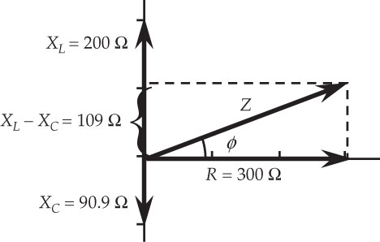

**ANS. FIG. P32.15**

**P32.16** We first determine the reactances of the circuit. The capacitive reactance is



the inductive reactance is,



and the impedance Z of the circuit is



The current in the circuit is then



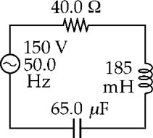

**ANS. FIG. P32.16**

(a) The maximum voltage between points *a* and *b* is the potential drop across the resistor:



(b) The maximum voltage between points *b* and *c* is the potential drop across the coil:



(c) The maximum voltage between points *c* and *d* is the potential drop across the capacitor:



(d) The potential drop between points *b* and *d* is



**\*P32.17 Conceptualize** Model the existing factory as the circuit shown in Figure 32.13, with the capacitor replaced by a simple wire. Unmodified Figure 32.13 represents the circuit for the factory with the proposed capacitor installed.

**Categorize** The factory is categorized as an AC circuit, so we can use the techniques we learned in this chapter.

**Analyze** (a) The power factor is given in Equation 32.35 as

 (1)

Incorporate Equation 32.28 for the impedance of the circuit:

 (2)

For the existing factory with no capacitive load, *XC* = 0, and

 (3)

Incorporate Equation 32.13 for the inductive reactance:

 (4)

Substitute numerical values for your demonstration circuit:



(b) Now, to make the power factor equal to 1.00, we need to have the impedance equal the resistance, which we can do by demanding that *XC* = *XL*:

 (5)

Substitute numerical values for your demonstration circuit:



(c) Finally, to convince the owners of the increased power to the factory, show them the ratio of the power with the capacitor to that without. Assuming the supply voltage stays the same, use Equation 32.34:

 (6)

Use an rms version of Equation 32.29 for the currents:

 (7)

Use Equation (1) to substitute for the power factors:

 (8)

Substitute for the impedances:

 (9)

Substitute numerical values:



Notice that the simple addition of the capacitance results in a 22% increase in power delivered to the demonstration circuit.

**Finalize** Keep in mind that this is a demonstration circuit, and scaling up to a factory-sized circuit may entail many practical considerations that are not present in a small circuit.

*Answers:* (a) 0.905 (b) 281 **F (c) 22%

**P32.18** The Phasors for the three cases are shown in ANS. FIG. P32.18.

(a) 25.0 sin *ωt* at *ωt* = 90.0°

(b) 30.0 sin *ωt* at *ωt* = 60.0°

(c) 18.0 sin *ωt* at *ωt* = 300°

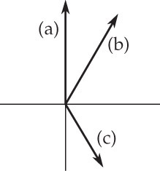

**ANS. FIG. P32.18**

**P32.19** The reactance of the inductor is



The reactance of the capacitor is



(a) 

(b) Since XL > XC,  is positive, so  This means that the power-supply or total voltage goes through each maximum, zero-crossing, and minimum earlier in time than the current does.

**P32.20** (a) The capacitive reactance of the circuit is



(b) The impedance of the circuit is



(c) 

(d) The phase angle in this *RC* circuit is



Since , .

(e) 

Section 32.6 Power in an AC Circuit

**P32.21** From the definition of impedance**,**  we have



Substituting numerical values,



The phase angle of the circuit is then



The rms current in the circuit is



Therefore, the power delivered to the circuit is



**P32.22** The power factor for a series *RLC* circuit is given by



The circuit in this problem has no capacitance, so the power factor becomes



In order for the power factor to be equal to 1.00, we would have to have *XL* = 0, which would require either *L* or *f* to be zero. Because this is not the case, the situation is impossible.

**P32.23** The rms current in the circuit is



and the average power delivered to the circuit is



**P32.24** Given  observe that  and *ω* = 350 rad/s. Also, the net reactance is



(a) To find the impedance, we first compute



so the impedance is



(b) The rms current in the circuit is



(c) The phase difference between the applied voltage and the current is



so the average power delivered to the circuit is



Section 32.7 Resonance in a Series RLC Circuit

**P32.25** (a) The resonance frequency of a *RLC* circuit is . Thus, the inductance is



(b) At resonance,



**P32.26** We are given *L* = 0.020 0 H, *C* = 100 × 10–9 F, *R* = 20.0 Ω, and   


(a) The resonant frequency for a series *RLC* circuit is

 

(b) At resonance,



(c) From Equation 32.43,



(d) At resonance, the amplitude of the voltage across the inductor is



**\*P32.27 Conceptualize** We can connect the capacitors in series or parallel. We need to determine which type of connection we need. It doesn’t matter how you connect the resistors, because the resonance frequency doesn’t depend on the resistance. The resistance will, however, determine the maximum current in the circuit at resonance as well as the *Q* factor.

**Categorize** We categorize the problem as a simple substitution problem.

The resonance frequency is given by Equation 32.39:



From this equation, we see that, to minimize the resonance frequency, you want to maximize the capacitance. Therefore, you should connect the capacitors in a parallel combination and attach that combination in series with the resistors and the inductor. Capacitors in parallel add, so the resonance frequency will be



where *C* is the capacitance of each individual capacitor that you have. Therefore, substituting numerical values,



To maximize the current, the resistors should be connected in parallel to provide the lowest possible equivalent resistance.

*Answer:* 1.41 × 105 rad/s

**P32.28** The resonance frequency is . Thus, if , then



and 

The impedance of the circuit is



so the rms current in the circuit is



The power delivered to the circuit is



and the energy delivered in one period is 



Substituting numerical values,



**P32.29** The resonance frequency is . Thus, if , then



and 

The impedance of the circuit is



so the rms current in the circuit is



The power delivered to the circuit is



and the energy delivered in one period is 



Section 32.8 The Transformer and Power Transmission

**P32.30** The rms primary voltage is



The rms voltage across the bigger coil is



**P32.31** The capacitive reactance of this “circuit” is



and the impedance is



The rms current is then



and the rms voltage across the person’s body is



**P32.32** (a) The total resistance of the transmission line is



and the rms current in the line is



The power loss during transmission is



(b) The fraction of input power lost is



(c)  Maximum power transfer occurs when load resistance equals the line resistance of 290 Ω, and is  far below the required 5 000 kW.

**Additional Problems**

**P32.33** From Equation 32.39, the resonance frequency for this circuit is



This frequency is not in the range of North American AM frequencies, which can be found from internet research to be 520 kHz – 1 610 kHz. The frequency above is appropriate for an North American FM radio station.

**P32.34** (a) The impedance is given by



From which we obtain



or





(b) The power delivered to the circuit is given by



If the power is decreased as the frequency is raised, then the impedance is increased, so the inductive reactance is greater than the capacitive reactance, and the circuit must be above resonance:



Therefore, the inductive reactance 700 Ω and the 

(c) Now,



Here *XC* = 700 – 733 = –33 Ω is impossible, but   
*XC* = 700 + 733 = 1433 = 1.43 kΩ is possible.



**P32.35** Consider a two-wire transmission line: each wire has resistance *R*, the total power transmitted is *P*, and the current in the wires is . The power loss is 1.00% of the transmitted power *P*. Therefore,



Solving for the resistance gives



The resistance of one wire is



Solving for the area gives



and the diameter is



**P32.36** Consider a two-wire transmission line: each wire has resistance *R*, the total power transmitted is *P*, and the current in the wires is . The fractional power loss is *f* of the transmitted power *P*. Therefore,





The resistance of one wire is



Solving for the area gives



and the diameter is



**P32.37** The turns ratio is the factor of change in voltage:



with 

we have 

(a) Since , we find



(b) 

**P32.38** The equation for during the first period (using *y* = *mx* + *b*) is:



Therefore,





Then, 

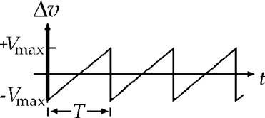

**ANS. FIG. P32.38**

**P32.39** (a) We can use  to find the sum of the two sine functions to be



Thus, the total wave has amplitude  and has a constant phase difference of  from the first wave.

(b) Refer to ANS. FIG. P32.39 (b). In units of cm, the resultant phasor is



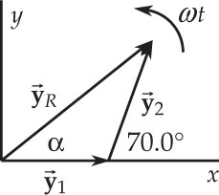

**ANS. FIG. P32.39 (b)**

(c) 

(d) Refer to ANS. FIG. P32.39 (d). Adding the three waves yields



The wave function of the total wave is



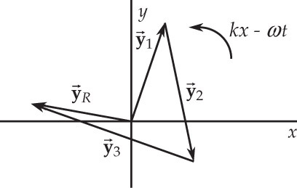

**ANS. FIG. P32.39 (d)**

**P32.40** (a) 

(b) 

(c) The equations are   and  From the inductive reactance,



then from the capacitive reactance,



solving for the angular frequency gives



from which we obtain



Then,



**P32.41** (a) The lowest-frequency standing-wave pattern is N-A-N. The distance between the clamps we represent as . The speed of transverse waves on the string is . The magnetic force on the wire oscillates at 60 Hz, so the wire will oscillate in resonance at 60 Hz. From the speed of transverse waves,



we obtain the period as





(b)  Any values of *T* and *d* related according to this expression will work. We did not need to use the value of the current and magnetic field.

**P32.42** (a) See the graph in ANS. FIG. P32.42(a).

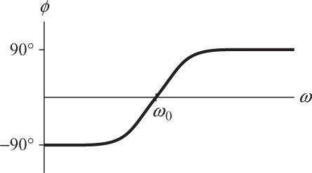

**ANS. FIG. P32.42 (a)**

(b)  changes from –90° for *ω* = 0 to 0 at the resonance frequency to +90° as *ω* goes to infinity.

The slope of the graph is *dφ*/*dω*:



(c) At resonance we have ; substituting, we find the slope at the resonance point is



where .

**P32.43** (a) The inductive reactance of the circuit is



(b) The capacitive reactance of the circuit is



(c) The impedance of the circuit is



(d) The maximum current is



(e) 

(f) 

(g) The power input into the circuit is



**P32.44** (a) With both switches closed, the current goes only through the generator and resistor.



(b) 

(c) 

(d) For ,

We require , so 

(e) The frequency is the resonance frequency: 

For parts (f) and (g), the circuit is at resonance, so *Z = R* and .

(f) To find the maximum energy stored in the capacitor, we start with



When *I* = *I*max,



(g) 

(h) Now , so



1. Now , so 

**\*P32.45 Conceptualize** The *RC* circuit shown here acts as a *low-pass filter* or a *high-pass filter*. At high frequencies, the capacitor has a low impedance, so most of the output voltage is across the resistor. Conversely, at low frequencies, the capacitor acts almost as an open circuit, so the output voltage is high across the capacitor.

**Categorize** This is a simple AC circuit, to which we apply the material from this chapter.

**Analyze** Based on the discussion in the Conceptualize step, we see that we attach the woofer to (a) the capacitor, and the tweeter to (b) the resistor.

(c) Set up the ratio of the magnitude of the output voltage across the resistor to the magnitude of the input voltage:



where we have used Equation 32.28 for the impedance, with *L* = 0.

(d) Follow the same procedure as we did in part (c), but for the capacitor output:



**Finalize** Notice the behavior of the expressions in parts (c) and (d) as the frequencies vary. In part (c), as the frequency *increases,* the ratio of the voltages *increases*; the tweeter should be connected to this output. In part (d), as the frequency *decreases*, the ratio of the voltages *increases*; the woofer should be connected to this output.

*Answers:* (a) capacitor (b) resistor (c)  (d) 

**P32.46** (a) We are given *XL* = *XC* = 1 884 Ω when *f* = 2 000 Hz. The impedance is then



and the capacitance is



therefore,





and



TABLE P32.46 lists the inductive reactance, the capacitive reactance, and the impedance for the frequencies listed in the problem statement.



**TABLE P32.46**

(b) ANS. FIG. P32.46 (b) shows a graph of *XL* , *XC* , and *Z* as a function of the frequency *f*.

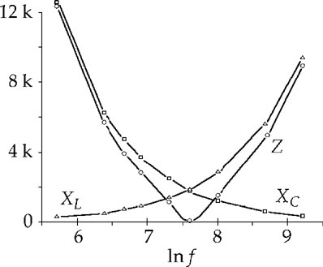

**ANS. FIG. P32.46 (b)**

**\*P32.47 Conceptualize** The circuit in Figure P32.47a is the *RLC* circuit that we analyzed in Section 31.6 and Figure 31.15, with the addition of switches in parallel with each of the three circuit elements. The circuit in Figure P32.47b is the *RLC* circuit driven by an AC source in Figure 32.13, again with the addition of the switches in parallel.

**Categorize** Based on the description in the Conceptualize step, we categorize the circuit as an *RLC* circuit, powered by a battery in Figure P32.47a and by an AC source in Figure P32.47b.

**Analyze** Consider Figure P32.47a first, with the battery as the energy source for the circuit. If switch S*L* is closed and S*C* and S*R* are open, there is a short circuit across the inductor, so the inductor plays no role in the circuit. Therefore, when switch S is thrown to the position *b*, the capacitor discharges through the resistor; the circuit is an *RC* circuit, and the time constant is given by Equation 27.20:

 (1)

If switch S*C* is closed and S*L* and S*R* are open, there is a short circuit across the capacitor, so the capacitor plays no role in the circuit. Therefore, when switch S is thrown to the position *b*, the circuit is an *RL* circuit, and the time constant is given by Equation 31.8:

 (2)

Now, let’s move to Figure P32.47b. With switch S at position *b*, the battery is no longer part of the circuit. Switches S*C*, S*L*, and S*R* are all open, so we can ignore them. What we have is an *RLC* circuit driven by an AC source, just like in Figure 32.13. From Equation 32.39, the resonance frequency of the circuit is

 (3)

Substitute Equations (1) and (2) into Equation (3):

 (4)

Substitute numerical values:



**Finalize** Look at how many quantities we did *not* know in this problem: **, *r*, *L*, *R*, and *C*! We also did not know the maximum voltage ∆*V*max of the AC source. Yet we were still able to find the answer. Notice the importance of solving problems algebraically before substituting numerical values. If you solve problems by substituting numbers at every step, you would have been stuck at Equation (1), because you don’t know *R*. But, by carrying the calculation through algebraically, we see that we only need the time constants in the final expression; we *don't need* *R*, or any of the other quantities.

*Answer:* 1.00 × 104 rad/s

**P32.48** (a) At resonance,



At that point,

Z = R = 1.00  and 

The power is

*P* = I2R = (1.00 A)2(1.00 ) = 1.00 W

We compute the power at some other angular frequencies, listed in TABLE P32.48.



**Table P32.48**

ANS. FIG. P32.48 shows a graph of the results tabulated above.

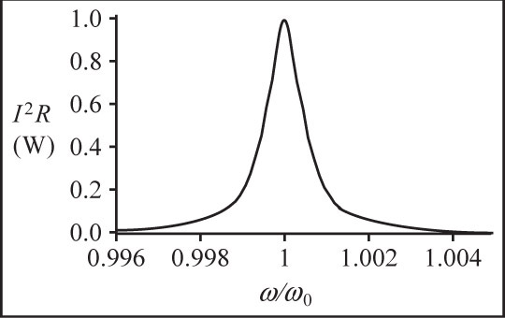

**ANS. FIG. P32.48**

(b) The angular frequencies giving half the maximum power are

0.999 5  106 rad/s and 1.000 5  106 rad/s

so the full width at half the maximum is

 = (1.000 5 – 0.999 5)  106 rad/s

 = 1.00  103 rad/s

Since 

and for comparison,



The two quantities agree.

**Challenge Problems**

**P32.49** We start with



Then, at 200 Hz,



and at 4 000 Hz,



At the low frequency, *XL* – *XC* < 0. This reduces to

 **[1]**

For the high frequency half-voltage point,

 **[2]**

Solving equations [1] and [2] simultaneously gives

(a) 

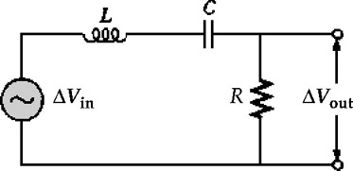

**ANS. FIG. P32.49(a)**

(b) 

(c) When *XL* = *XC*, 

(d) *XL* = *XC* requires



(e) ,  and *XC* > *XL*, so the phasor diagram is as shown in ANS. FIG. P32.49 (e).



so .

, *XL* = *XC* so

.

,  and *XL* – *XC* > 0.

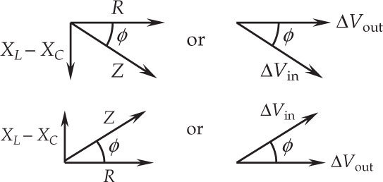

**ANS. FIG. P32.49 (e)**

Thus, 

or .

(f) At 200 Hz and at 4 kHz,



At *f*0,



(g) We take



**P32.50** (a) 

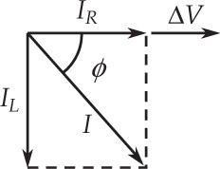

**ANS. FIG. P32.50**

(b) The total current will  the applied   
voltage as seen in the phasor diagram   
shown in ANS. FIG. P32.50.



Thus, the phase angle is:



**P32.51** We have , and



Therefore,



which is a fourth order equation in *ω*. But this can be simplified to two equations:



where .

We will solve for *ω* when  = 100 V and *P* = 250 W. From Figure P32.16, we have *R* = 40.0 Ω, *L* = 185 mH = 0.185 H, and *C* = 65.0 *µ*F = 65.0 × 10–6 F.

The quantity *A* is



The angular frequency *ω* must be positive, so we solve for the positive roots. (In the following, we suppress all units.)

For 



For 



There are two answers because the circuit can be either above or below resonance.

|  |
| --- |
| **ANSWERS TO QUICK-QUIZZES** |

**1. (i)** (c) **(ii)** (b)

**2.** (b)

**3.** (a)

**4.** (b)

**5.** (a) *XL*  < *XC* (b) *XL* = *XC* (c) *XL* > *XC*

**6.** (c)

**7.** (c)

|  |
| --- |
| **ANSWERS TO EVEN-NUMBERED PROBLEMS** |

**P32.2** (a) 170 V; (b) 2.40 × 102 Ω;   
(c) Because , a 100-W bulb has less resistance than a 60.0-W bulb.

**P32.4** (a) The rms current in each 150-W bulb is 1.25 A. The rms current in the 100-W bulb is 0.833 A; (b)  (c) 36.0 Ω

**P32.6** (a) 0.0424 H; (b) 942 rad/s

**P32.8** 3.80 J

**P32.10** 

**P32.12** (a) 221 Ω; (b) 0.163 A; (c) 0.230 A; (d) no

**P32.14** 

**P32.16** (a) 146 V ; (b) 212 V; (c) 179 V; (d) 32.4 V

**P32.18** See P32.18 for explanation.

**P32.20** (a) 88.4 Ω; (b) 107 Ω; (c) 1.12 A; (d) the voltage lags behind the current by 55.8°; (e) Adding an inductor will change the impedence, and hence the current in the circuit. The current could be larger or smaller, depending on the inductance added. The largest current would result when the inductive reactance equals the capacitive reactance, the impedance has its minimum value, equal to 60.0 Ω, and the current in the circuit is



**P32.22** See P32.22 for full explanation

**P32.24** (a) 66.8 Ω; (b) 0.953 A; (c) 45.4 W

**P32.26** (a) 3.56 kHz; (b) 5.00 A; (c) 22.4; (d) 2.24 kV

**P32.28** 

**P32.30** 687 V

**P32.32** (a)(b) 

(c) 

**P32.34** (a) 

(b)  (c) 

**P32.36** 

**P32.38** 

**P32.40** (a) Higher. At the resonance frequency, *XL* = *XC*. As the frequency increases, *XL* goes up and *XC* goes down; (b) It is possible. We have three independent equations in the three unknowns *L*, *C*, and the certain *f* ; (c) *L* = 4.90 mH and *C* = 51.0 *µ*F

**P32.42** (a) See ANS. FIG. P32.42(a); (b) ; (c) See P32.42 (c) for full explanation.

**P32.44** (a)  (b) 

(c)  (d) ; (e) *R*;   
(f)  (g)  (h)  (i) 

**P32.46** (a) See Table P32.46; (b) See ANS. FIG. P32.46 (b).

**P32.48** (a) See ANS. FIG. P32.48; (b) See P32.48 for full explanation.

**P32.50** (a) 1.25 A; (b) lag, 46.7°